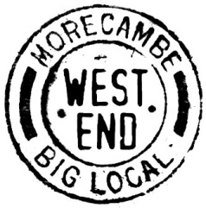
West End Morecambe Big Local
Mental Health activity
Ideas from less well-established groups

We recognise that there might be small or new West End groups who may have ideas related to mental health but are not confident about how to take them forward. Our commission and form may not be suitable for such less well-established groups.

Nevertheless, we would be glad to hear about such Mental Health ideas. We promise to look at all suggestions and, if something fits, we will try and find a way to help or to point you to other avenues of support.

Please fill in the form below and email it to admin@westendmorecambe.co.uk

1. Your group

A contact name
Telephone
Email
Does your group have a name, if so, what is it?
What does the group do?
How long has it existed?
How many people are involved in the group?
What geographic area does your group cover?

2. Your project idea
1. What is your Mental health project idea?
2. Who would it help?
3. Why do think there is a need for this project?
4. Have you talked to any other group or organisation about your ideas?
5. Is for anything else you wish to say, please add it here.

Note
- Your organisations details are for private use only and will not be shared outside of WEM without your permission.

- We generally only support groups that target the West End but will support groups that cover a wider area and have members or users in the West End.

- If you have any questions, please email them to the contact at the top.

- This form should be returned by Monday 24th April 2023 electronically to admin@westendmorecambe.co.uk or as a hard copy to: WEM, c/o LDCVS, The Cornerstone, Sulyard Street, Lancaster, LA1 1PX.

